Lab 3

Task 1a

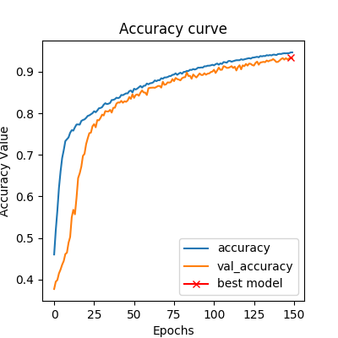 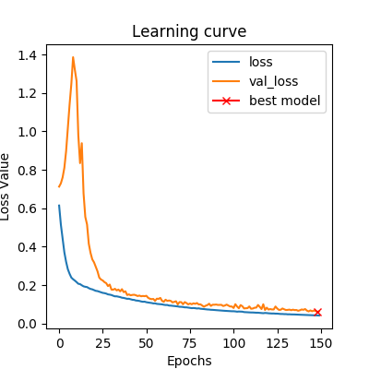

Lung Segmentation in Chest X-ray Images – Metric- Dice Coefficient

Loss Function- Binary Cross Entropy

Task 1b

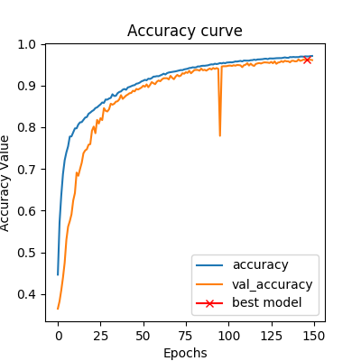 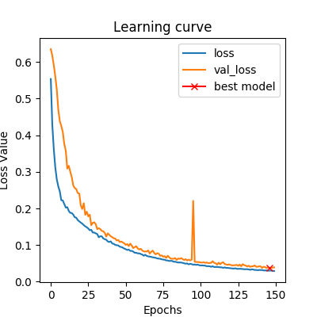

Lung Segmentation in Chest X-ray Images – Metric- Dice Coefficient

Loss Function- Dice Loss

The validation loss for the model with loss function as Dice Loss (0.038) is lower than validation loss for the model with loss function as Binary Cross Entropy(0.065), over 150 epochs.

The Dice Coefficient for the model with loss function as Dice Loss(0.961) is higher than the dice coefficient of the model with loss function as Binary Cross Entropy(0.933), over 150 epochs.

Task 2

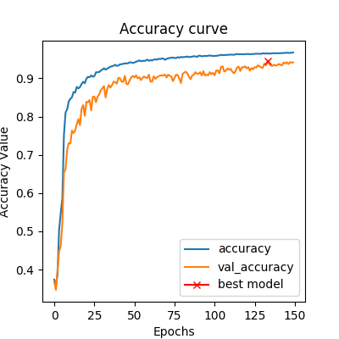 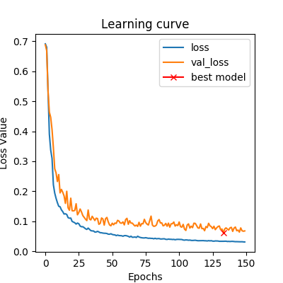

Lung Segmentation in Chest X-ray Images – Metric- Dice Coefficient

Loss Function- Binary Cross Entropy, without batch normalization

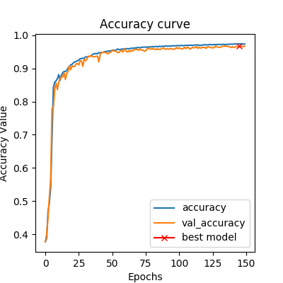 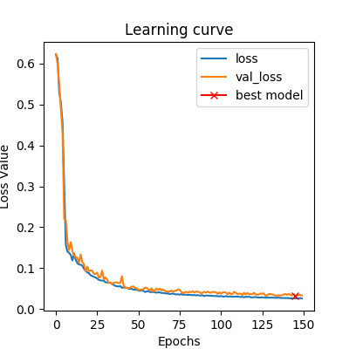

Lung Segmentation in Chest X-ray Images – Metric- Dice Coefficient

Loss Function- Dice Loss, without batch normalization

* The performance for the model with loss function as Binary Cross Entropy is better without batch normalization. The performance has been compared below.

Loss Function – Binary Cross Entropy, with batch normalization

Validation Loss – 0.065

Validation Dice Coefficient – 0.933

Loss Function – Binary Cross Entropy, without batch normalization

Validation Loss – 0.066

Validation Dice Coefficient – 0.943

* The performance for the model with loss function as Dice Loss is better without batch normalization. The performance has been compared below.

Loss Function –Dice Loss, with batch normalization

Validation Loss – 0.0381

Validation Dice Coefficient – 0.961

Loss Function –Dice Loss, without batch normalization

Validation Loss – 0.033

Validation Dice Coefficient – 0.966

Generally, batch normalization is used to speed up the training process but in segmentation we did not observe a major difference between the model with and without batch normalization.

Task 3

Best Setting: Loss Function – Dice Loss, Without Batch Normalization

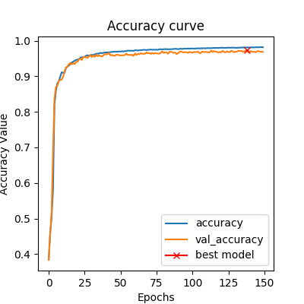 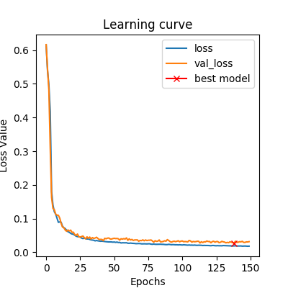

The segmentation accuracy ( Dice coefficient) of the model on validation set is 0.969 which is higher than the Dice Coefficents (on validation data) of the previous models.

However, the improvement is very minimal and by increasing the base from 16 to 32, we are doubling the number of features. This is leading to more memory consumption and slowing down the process of training which in this case is not worth it because the improvement in dice coefficient is negligible.

Increasing the base too much could lead to overfitting and not having a base large enough could lead to underfitting by taking away the network’s power to learn. The best to choose the number of feature maps is finding a compromise between the two situations with hit and trial and then check the model’s performance on a test set.

Task 4

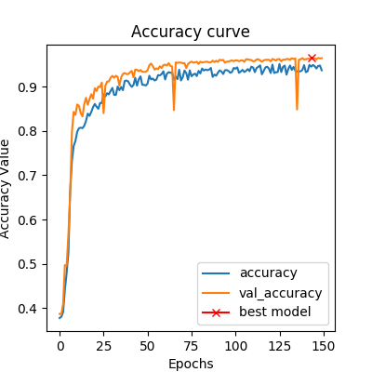 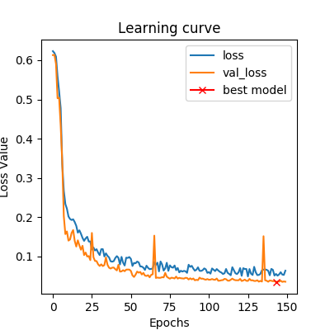

Lung Segmentation in Chest X-ray Images – with best parameters and

Data augmentation

For this particular dataset, the data augmentation does not seem to help as the validaiton dice score of the model (0.964) is lower than that in Task 3 (0.969). The validation loss of the model in task 4 (0.035) is higher than the validation loss of the model in task 3(0.030). Both the models have a very similar performace and the model with data augmentation

The model in task 4 seems to have a good generalization power as it is not overfitting. Model in task 3 seems to have a better genarilazation power so the model in task 4 is not particularly an improvement.

Task 5a

Dice Coefficient : 0.9456

Validation Loss :0.0543

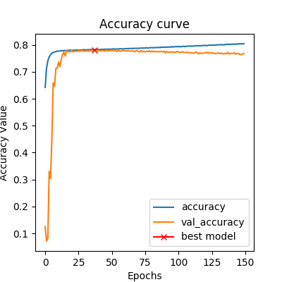 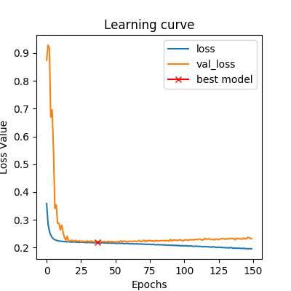

Lung Segmentation In CT Images

The sementation results of X-ray images are better than the segmentation results of the CT-

Images.

Task 5b

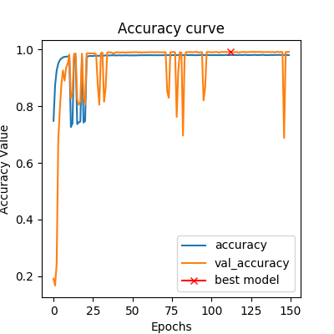 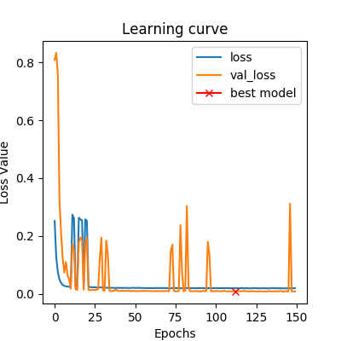

Dice Coefficient Curve Loss Curve

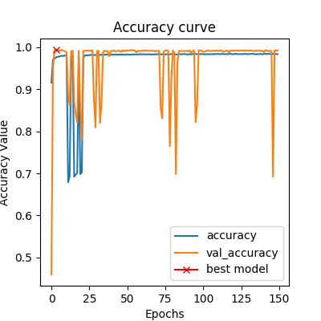 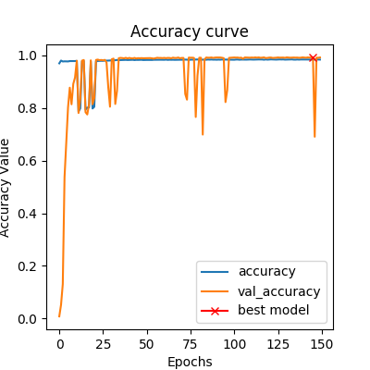

Precision Curve Recall Curve

Task 6

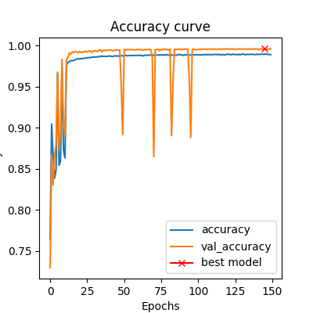 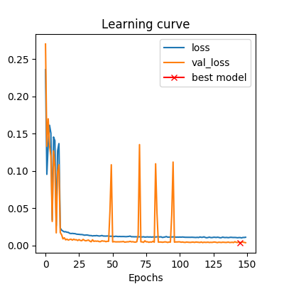

Dice Coefficient Curve Loss Curve

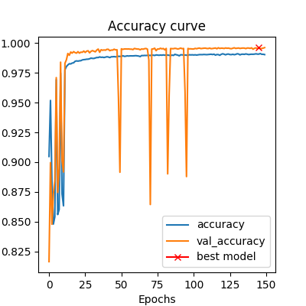 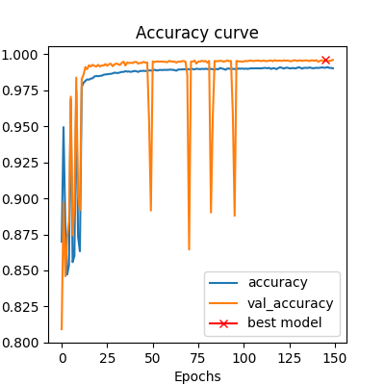

Precision Curve Recall Curve

Task 7

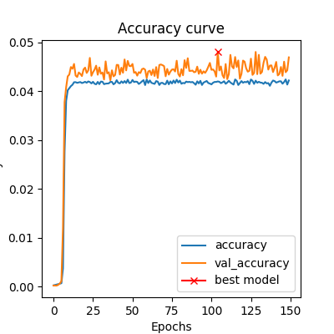 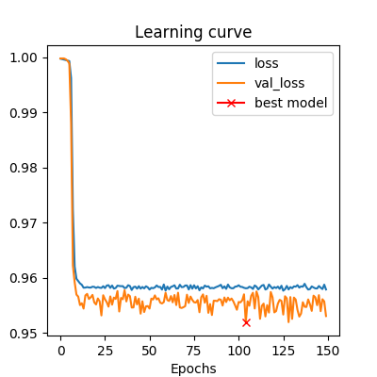

Dice Coefficient Curve Loss Curve

Brain Tumor Segmentation in MRI Images